Jenkins pipeline notes

Implementation of Jenkins pipeline script covers multiple aspects of knowledge.

. jenkins configuration includes plugin installation, global pipeline libraries, artifactory, parameter binding, multibranch and credential, remote server setting, publish over ssh setting etc

. jenkinsfile defines the overall workflow.

. either declarative or scripted approach implements the detail of steps in stage.

. shell script to implement deployment including kill service, download artifactories and start services

This is the sample jenkinsfile:



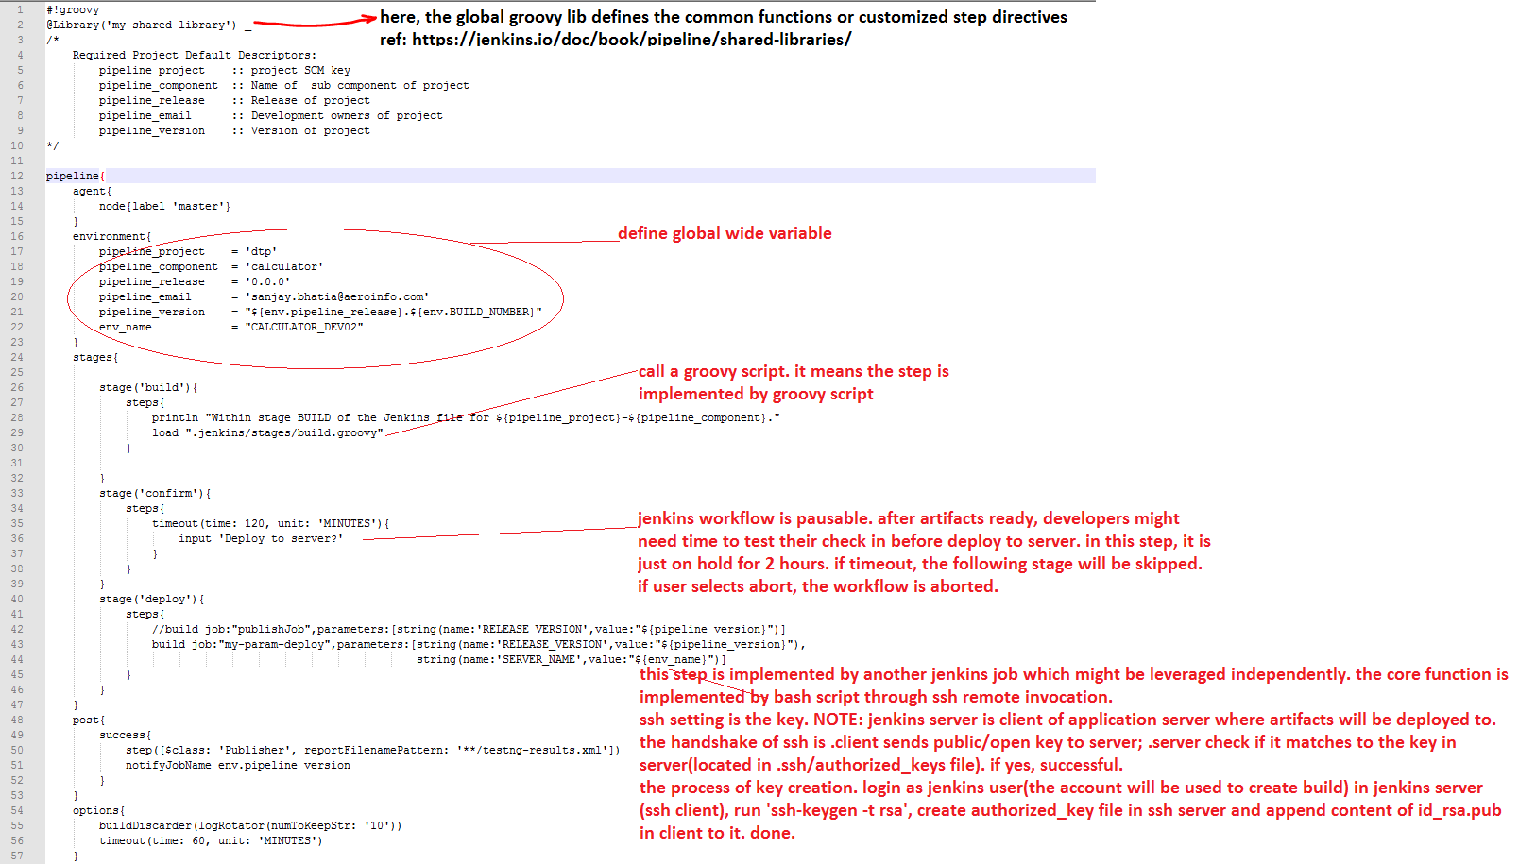

Configuration of jenkins

Here, I just focus on how to set deployment since the stages of above it is relatively simple. It just calls the maven build.

. set publish over ssh

Add public key into authorized_keys file in application servers.

Add shell script for deployment